Name: Nafinur Leo

Id: 20-42195-1

Serial Number: 24

CAD[J]

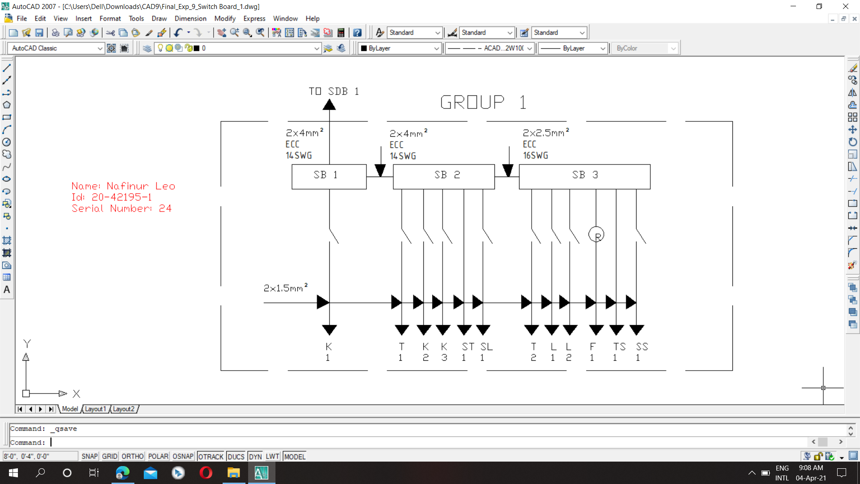

Figure: Switch Board Connection Diagram_Group 1

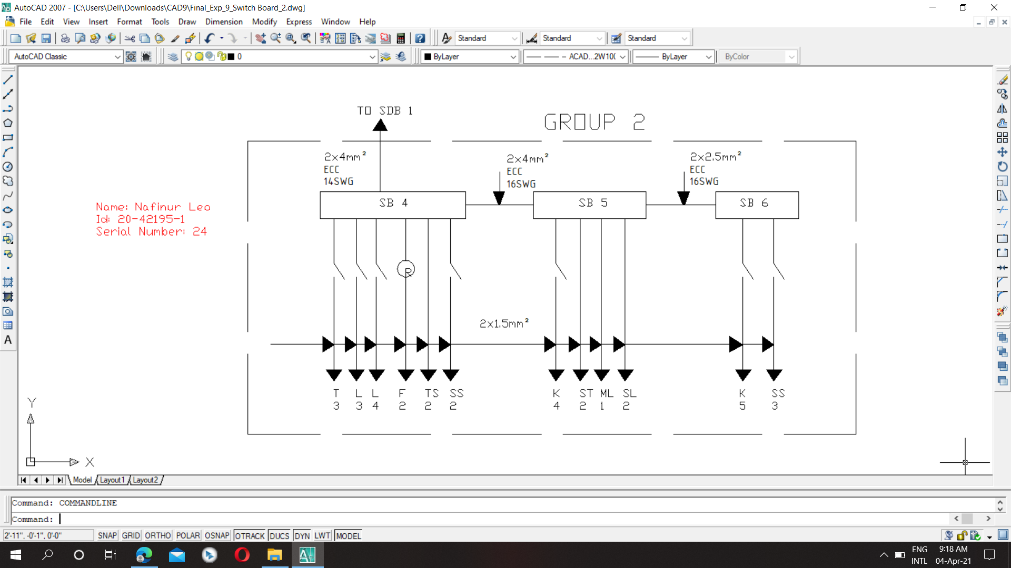

Figure: Switch Board Connection Diagram_Group 2

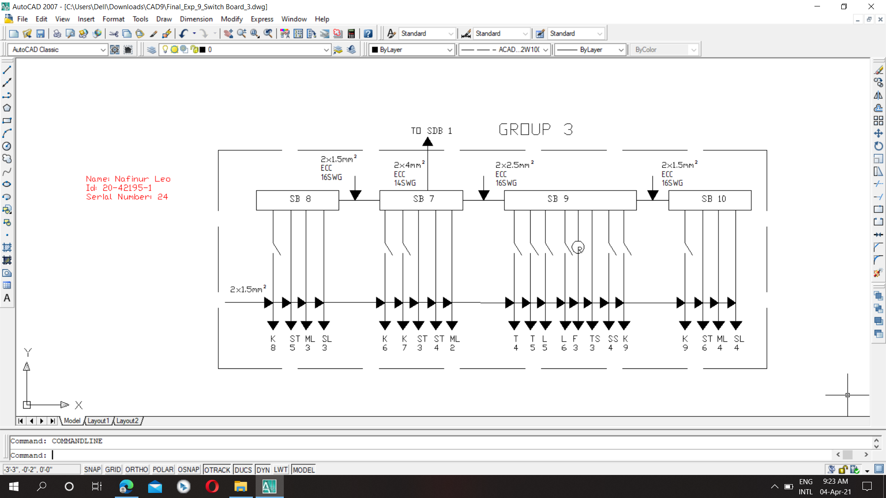

Figure: Switch Board Connection Diagram_Group 3

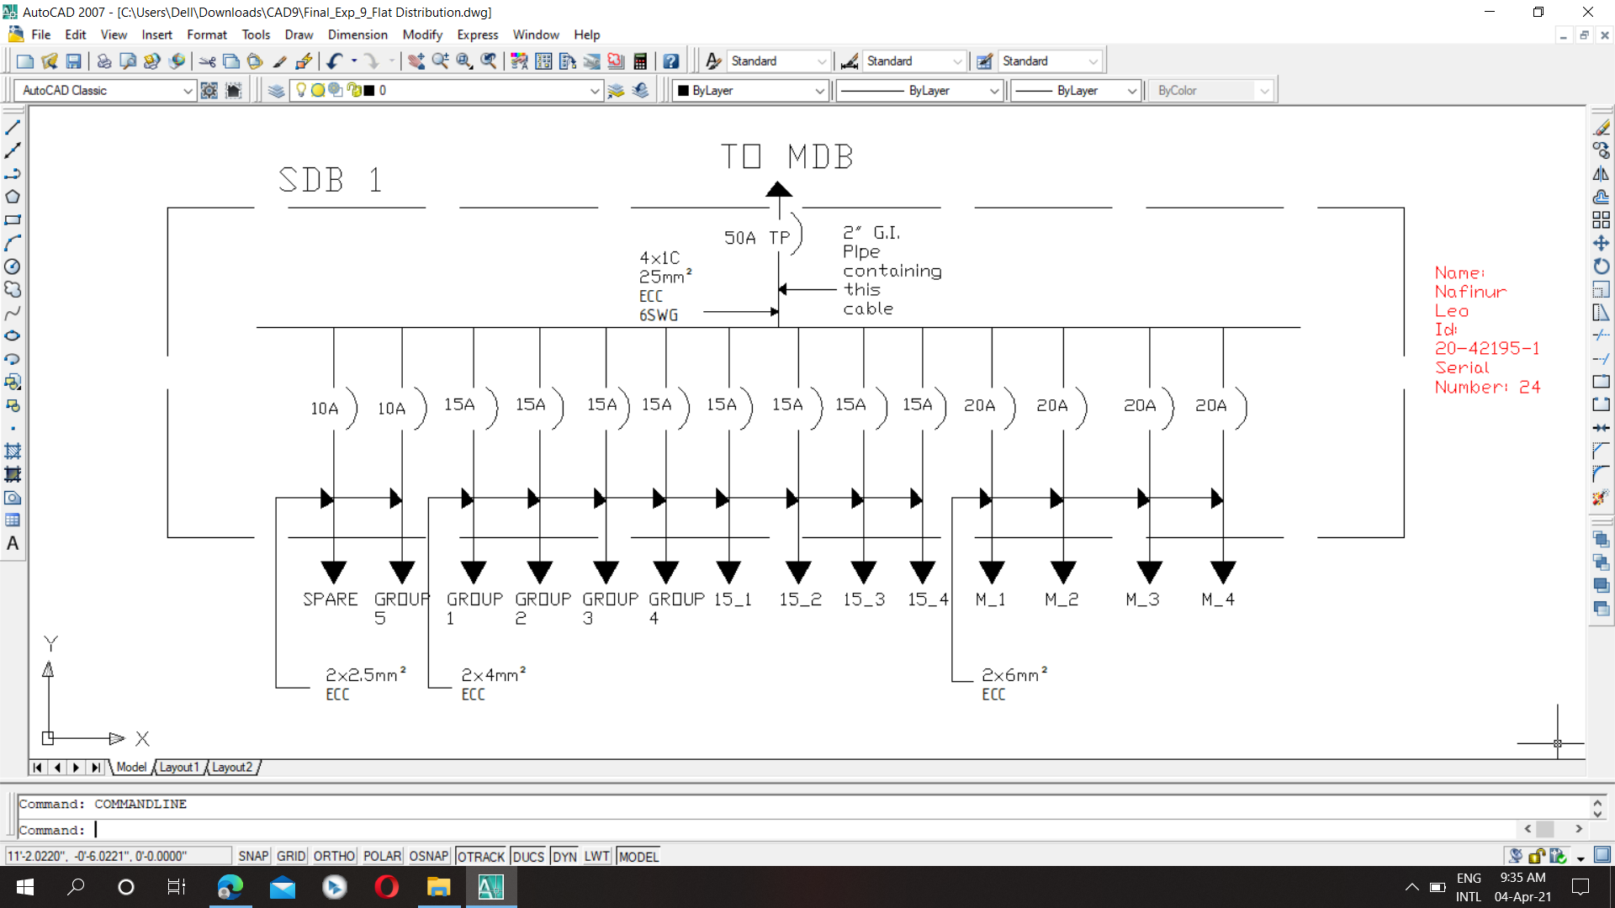

Figure: Flat Distribution Board Connection Diagram

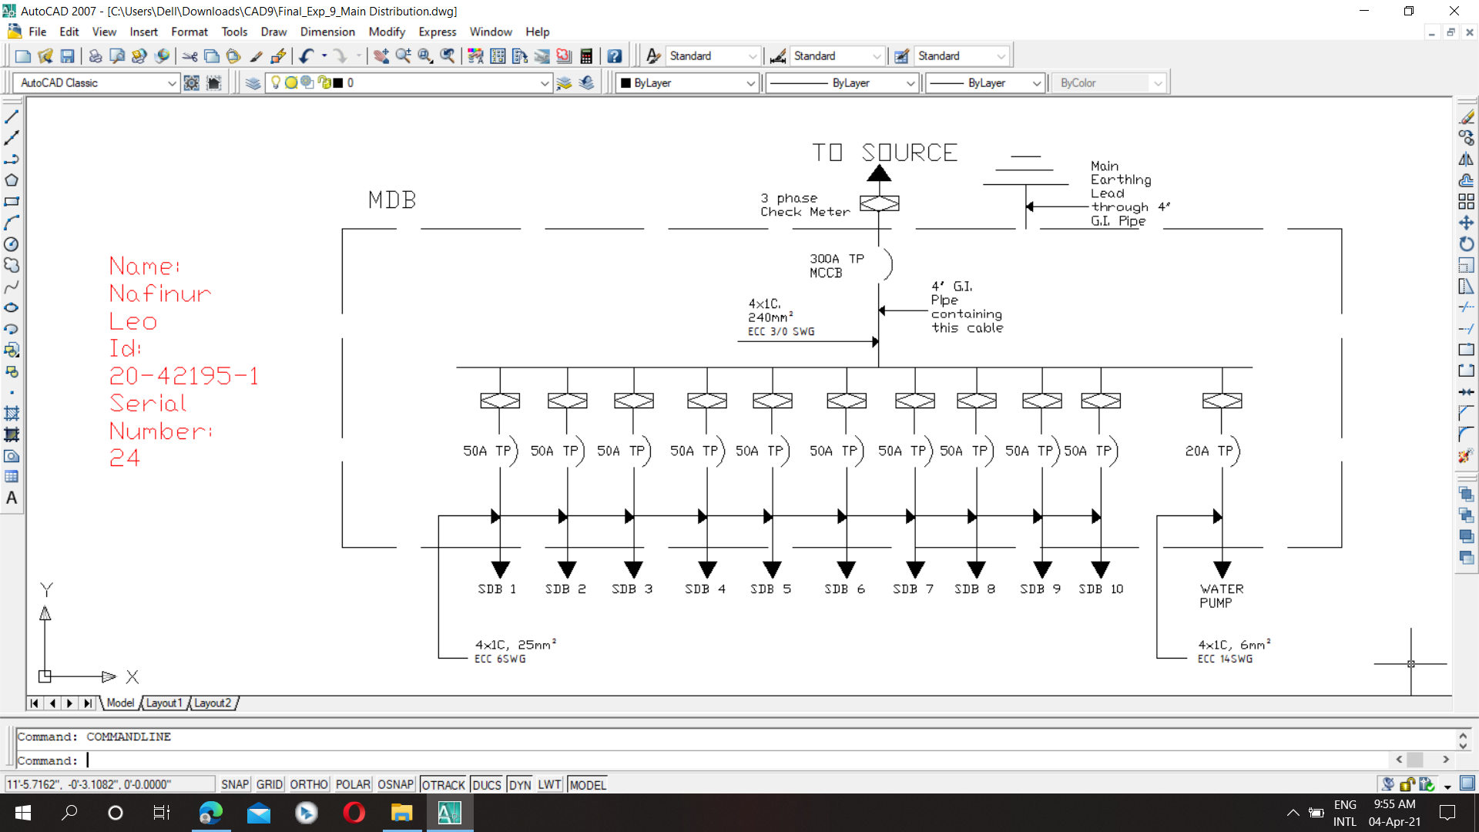

Figure: Main Distribution Board Connection Diagram